**Madagascar country profile**

Published

15 November 2019

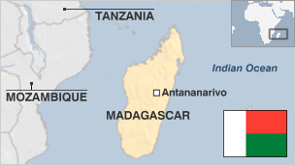

**Situated off the southeast coast of Africa, Madagascar is the fourth largest island in the world. Having developed in isolation, the island nation is famed for its unique wildlife.**

Traditionally, the Malagasy economy has been based on the cultivation of paddy rice, coffee, vanilla and cloves.

But, despite a wealth of natural resources and a tourism industry driven by its unique environment, the country remains one of the world's poorest, and is heavily dependent on foreign aid.

Since gaining independence from France in 1960, Madagascar has experienced repeated bouts of political instability, including coups, violent unrest and disputed elections.

The most recent coup in 2009 led to five years of political deadlock, international condemnation and economic sanctions.

Read [more country profiles](http://news.bbc.co.uk/1/hi/country_profiles/) - Profiles by [BBC Monitoring](http://www.bbc.co.uk/monitoring)

**President: Andry Rajoelina**

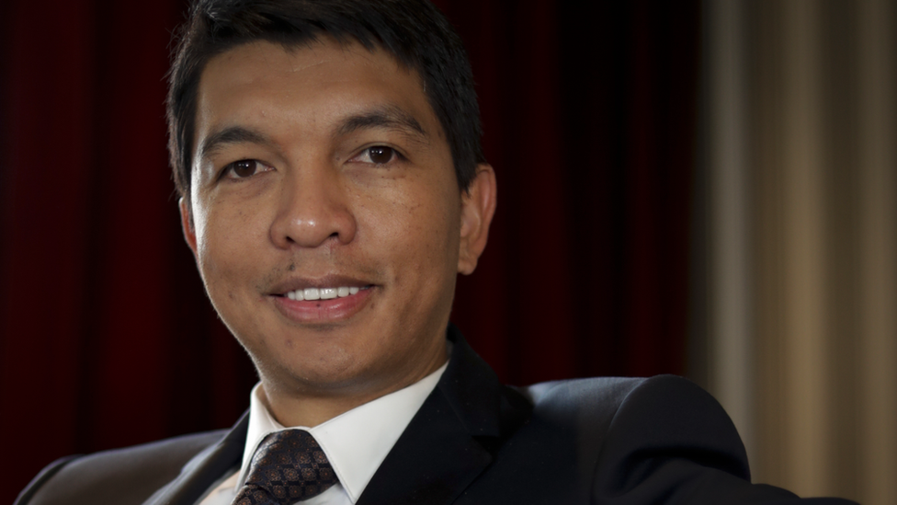image copyrightThomas Samson/AFP/Getty Images

image captionMr Rajoelina earlier ran Madagascar as head of an interim authority in 2009-2014

Businessman Andry Rajoelina took office as president in January 2019, ending a decade of political turbulence that began with his ouster of President Marc Ravalomanana in 2009.

The feud between the two men came to a head that year, when President Ravalomanana dismissed Mr Rajoelina as mayor of the capital Antananarivo.

The ousted mayor in turn spearheaded a popular and military revolt that drove the president into exile.Mr Rajoelina ruled as head of an interim authority that struggled with international sanctions until 2014, when an often difficult process of accommodation between rival political camps led to him ceding power to elected President Hery Rajaonarimampianina.

Mr Rajoelina then defeated both President Rajaonarimampianina and Mr Ravalomanana in a presidential election in late 2018.

The media are highly-politicised and vulnerable to influence from their owners, says Reporters Without Borders.

Radio is a key news source. Around 10% of Madagascans are online.

# Madagascar profile - Timeline

Published

5 November 2018

## A chronology of key events

**1880s-1905** - Colonial France consolidates its hold over Madagascar in the face of local resistance.

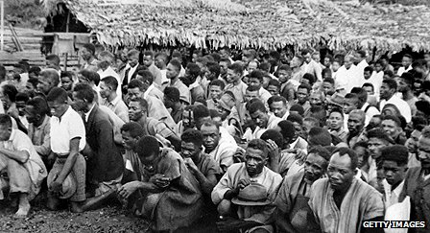image copyrightGetty Images

image captionPro-independence activists arrested during the 1947 rebellion

**1910-20** - Growth of nationalism fuelled by discontent over French rule.

**1946** - Madagascar becomes an Overseas Territory of France.

**1947** - French suppress armed rebellion in east. Thousands are killed.

**1958** - Madagascar votes for autonomy.

## Independence

**1960 26 June** - Independence with Philibert Tsiranana as president.

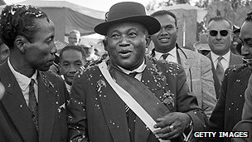image copyrightGetty Images

image captionPhilibert Tsiranana, Madagascar's first president

**1972** - Amid popular unrest, President Tsiranana dissolves government and hands power to army chief Gen Gabriel Ramanantsoa as head of a provisional government. He reduces the country's ties with France in favour of links with the Soviet Union.

**1975 June** - Lieutenant-Commander Didier Ratsiraka is named head of state after a coup. The country is renamed the Democratic Republic of Madagascar, and Mr Ratsiraka is elected president for a seven-year term.

**1976** - President Ratsiraka nationalises large parts of the economy, and forms the Arema party. Over the years he increases state control over the economy until 1986, when he changes tack and promotes market reforms.

**1992** - Under pressure of demonstrations, President Ratsiraka introduces democratic reforms. A new constitution is approved by referendum.

**1993** - Opposition leader Albert Zafy is elected president.

**1995** - Fire destroys most of Rova complex of royal tombs and palaces in Antananarivo, shortly before it was to receive UN World Heritage Site status. Reconstruction work continues.

**1996** - President Zafy is impeached, and Mr Ratsiraka is voted back into office.

**2000** March - Thousands are left homeless after two cyclones hit the island and Mozambique.

**2001** May - Senate reopens after 29 years, completing the government framework provided for in the 1992 constitution, which replaced the socialist revolutionary system.

The new framework comprises the presidency, national assembly, senate and constitutional high court.

## Election stand-off

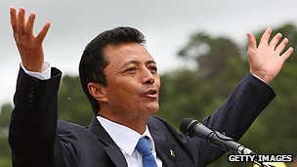image copyrightGetty Images

image captionMarc Ravalomanana was ousted after opposition protestors died in clashes with security forces

**2001** December - First round of presidential elections. Opposition candidate Marc Ravalomanana claims an outright victory and says there's no need for a second round.

**2002** February - Mr Ravalomanana declares himself president after weeks of political deadlock with President Ratsiraka over the December polls, which he says the government rigged. Violence breaks out between rival protesters.

**2002** April - The Constitutional Court declares Marc Ravalomanana winner of the December polls after a recount. Didier Ratsiraka says he'll ignore the verdict. In June the US recognises Mr Ravalomanana as legitimate leader of Madagascar.

**2002** July - Mr Ratsiraka seeks exile in France, marking the end of the seven-month political crisis.

**2002** December - Ravalomanana's party, I Love Madagascar (TIM), wins a parliamentary majority in elections which are seen as a test of popular support.

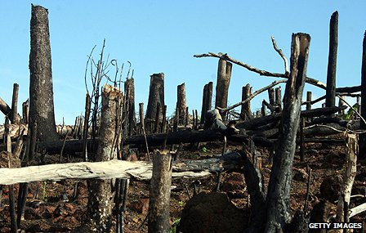image copyrightGetty Images

image captionDeforestation poses a serious threat to local people and the environment

**2004** February/March - Tropical cyclones Elita and Gafilo hit; thousands are left homeless.

**2004** October - World Bank, International Monetary Fund say they're writing off nearly half of Madagascar's debt - around $2bn.

**2005** March - Madagascar is the first state to receive development aid from the US under a scheme to reward nations considered by Washington to be promoting democracy and market reforms.

## Ravalomanana re-elected

**2006** December - Marc Ravalomanana wins a second presidential term.

**2007** April - Voters in a referendum endorse constitutional reforms to increase presidential powers and make English an official language.

**2007** July - President Ravalomanana dissolves parliament after new constitution calls for end to autonomy of provinces.

**2007** September - President Ravalomanana's I Love Madagascar (TIM) party wins 106 seats out of 127 in early parliamentary elections.

**2007** November - President Ravalomanana opens 3.3 billion dollar nickel cobalt mining project in Tamatave. Mine said to be largest of its kind in the world.

**2008** Feb-March - Cyclone Ivan, second of the season and one of the largest to hit the island kills 93 and leaves 332,391 homeless. UN launches flash appeal for $36.4 million to help cyclone-hit areas in the country.

**2008** March - Madagascar produces first barrels of crude oil in 60 years and at a time of record oil prices. The government issued 19 licenses to search for offshore oil since previous August.

## Unrest

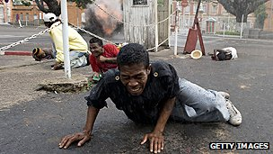image copyrightGetty Images

image captionDozens of people were killed in anti-government demonstrations in 2009

**Rise of Rajoelina**

**2009** January - Dozens are killed as a result of violent protests in Antananarivo following the closure of opposition TV and radio stations.

Opposition leader Andry Rajoelina calls on the president to resign, and proclaims himself in charge of the country.

**2009** March - Andry Rajoelina assumes power with military and high court backing after another month of violent protests.

President Ravalomanana flees to South Africa. Move is condemned internationally and isolates Madagascar.

**2011** November - New unity government is unveiled. Opposition parties agree to join new government "with reservations".

**2014** January - Hery Rajaonarimampianina sworn in as president after elections.

**2018** May - Supreme Court scraps electoral laws that sparked weeks of demonstrations and death of two protesters.

**2019** January - Andry Rajoelina wins presidential election, defeating President Rajaonarimampianina and his long-standing rival Marc Ravalomanana.